**CPEG 222**

**Project 2 Flow Chart**

Katie Black

Byron Lambrou

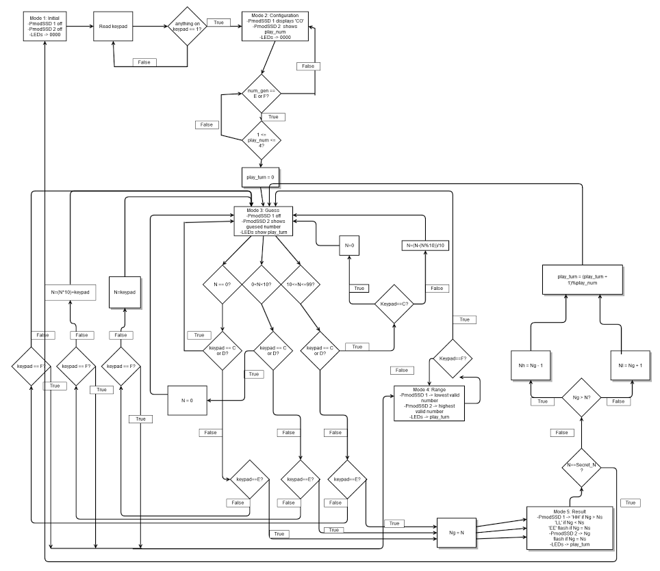

Questions to Address:

Question 1: In Lab1, a timer interrupt was used. A timer interrupt occurs after a certain number of clock cycles (specified by the timer parameters) have passed. In this lab we are using a Change_Notice interrupt. A Change_Notice interrupt is generated in response to a change of state on selected input pins. When we press a button the keypad, this will change the value of a keypad pin, which will generate an interrupt corresponding to keypad input, which we can then process accordingly.

Question 2: The keypad takes inputs on the column pins, and gives outputs on the row pins. In order to determine which key is pressed, we will output logic low to all of the column pins. Then, in the event that a button is pressed, we will receive a change_notice interrupt, because the value of the corresponding row pin will have changed. Once we have received the interrupt, we can sweep through the column pins, putting a logic low voltage to only one pin at a time. If only one button is pressed, then the row pin will have a logic low voltage only when the column pin corresponding to the button is also at logic low.

Question 3: 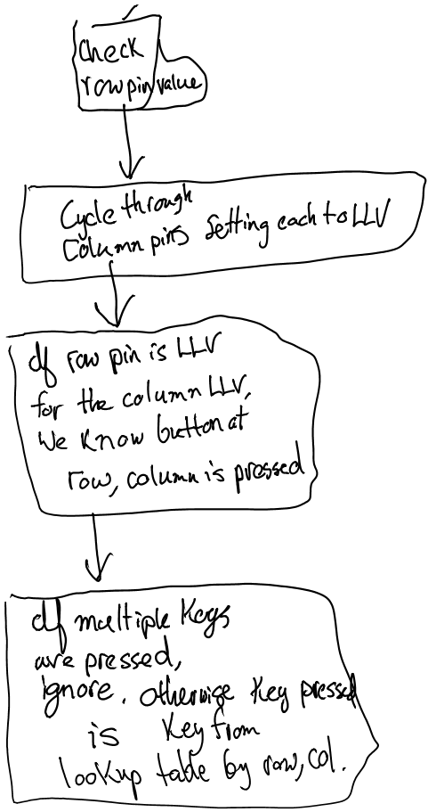

Question 4: Given some random number between 0 and 99, we can always guarantee success in at most 7 guesses. The strategy is a simple binary search algorithm. First, guess 50. If the random number was 50, then we are immediately successful. Elsewise, we are told whether we should go higher or lower. We then know the new bounds where the random number may lie are between 0 and 49, or 51 and 99. In either case, simply add the bounds together, then divide by two, and take the ceiling of this number. If the initial case were that the number were lower than 50, then the next guess would be 25=ceil(24.5=49/2). Supposing the secret number is less than 25, the new bounds are 0-24. If we continue with this approach we will always find the number with at most ceil(log_2(100)) comparisons, which is 7. This works because we can treat the possible values of the secret number as an ordered array from 0-99 for which we are searching for some value N_s, the secret number value.